7.31: The magnitude of the friction force on the book is
- The work done during each part of the motion is the same, and the total work done is 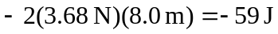 (rounding to two places). b) The magnitude of the displacement is 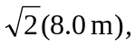 so the work done by friction is 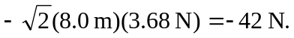 c) The work is the same both coming and going, and the total work done is the same as in part (a),  d) The work required to go from one point to another is not path independent, and the work required for a round trip is not zero, so friction is not a conservative force.

